

Name: Khizar Ali Roll No: 22P-9269

Subject: Programing Fundamentals LAB

Submitted to:

Problem: 1

Write a program that reads two integers from user and outputs the largest one using if else.

#include<stdio.h>

int main()

{

int num1,num2;

printf("Enter 1st number \n");

scanf("%d",&num1);

printf("Enter 2nd number \n");

scanf("%d",&num2);

if (num1>num2)

printf("%d is greater \n",num1);

else

printf("%d is greater \n",num2);

return 0;

}

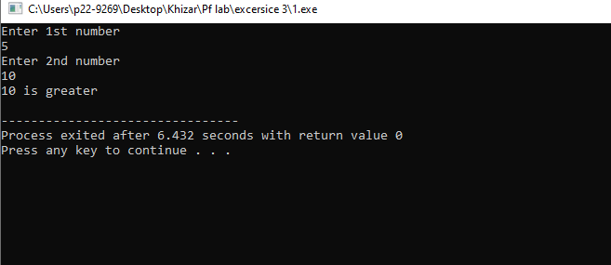

Problem: 2

Write a program that reads three integers from user and outputs the largest one.

#include<stdio.h>

int main()

{

int num1,num2,num3;

printf("Enter 1st number \n");

scanf("%d",&num1);

printf("Enter 2nd number \n");

scanf("%d",&num2);

printf("Enter 3rd number \n");

scanf("%d",&num3);

if (num1>num2 && num1>num3)

printf("%d is greater \n",num1);

else if(num2>num1 && num2>num3)

printf("%d is greater \n",num2);

else

printf("%d is greater \n",num3);

return 0;

}

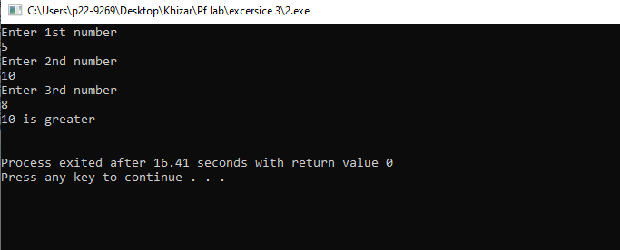

Problem: 3

Write a program that reads the score of a student in a subject and displays his grades according

to the following criteria:

#include<stdio.h>

int main()

{

int marks;

printf("Enter marks of a subject \n");

scanf("%d",&marks);

if (marks>=90)

printf("Your Grade is A+ \n");

else if (marks>=80)

printf("Your Grade is A \n");

else if (marks>=70)

printf("Your Grade is B \n");

else if (marks>=60)

printf("Your Grade is C \n");

else if (marks>=50)

printf("Your Grade is D \n");

else

printf("Your Grade is F \n");

return 0;

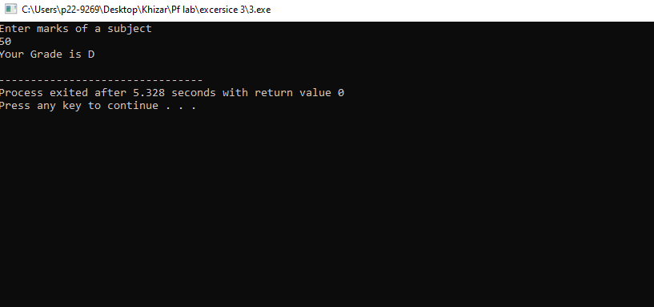}

Make a Simple Calculator to Add, Subtract, Multiply or Divide Using if else.

Your program ask user to enter the number and the operation you want to perform (+,-,*,/,%)

**#include<stdio.h>**

**int main()**

**{**

**int sum, product, divide,subtract;**

**int a , b ;**

**char c;**

**printf("Enter the operation you want to perform (*,+,-,/) \n ");**

**scanf("%s",&c);**

**printf("Enter value of a \n ");**

**scanf("%d",&a);**

**printf("Enter value of b \n ");**

**scanf("%d",&b);**

**if(c=='+')**

**{**

**sum=a+b;**

**printf("%d + %d = %d \n", a , b , sum );**

**}**

**else if(c=='-')**

**{**

**subtract=a-b;**

**printf("%d - %d = %d \n", a , b , subtract );**

**}**

**else if(c=='*')**

**{**

**product=a*b;**

**printf("%d * %d = %d \n", a , b , product );**

**}**

**else**

**{**

**divide=a/b;**

**printf("%d / %d = %d \n", a , b , divide );**

**}**

**return 0;**

**}**

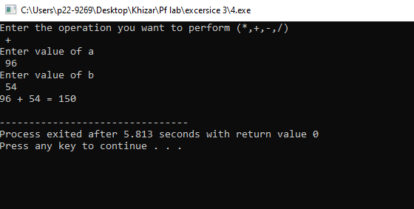

Problem: 5

Write a program to check a triangle is equilateral, isosceles or scalene. Your program

should ask the user to input x,y,z values

#include<stdio.h>

int main()

{

int a , b ,c ;

printf("Enter value of a \n ");

scanf("%d",&a);

printf("Enter value of b \n ");

scanf("%d",&b);

printf("Enter value of c \n ");

scanf("%d",&c);

if(a==b&&a==c)

{

printf("The triangle is equiletral \n" );

}

else if((a!=b&&a!=c)&&(b!=a&&b!=c)&&(c!=a&&c!=b))

printf("The triangle has 3 unequal sides \n" );

else

{

printf("The triangle is isoscale \n ");

}

return 0;

}

